bGeigieZen NFW: Simplified Assembly Guide

Safety Warnings
- Work in a well-ventilated area (solder smoke is hazardous)
- Wear safety glasses when cutting leads
- Soldering iron temperature: 200-350°C (400-650°F)
- Handle components gently, especially the LND_7317 pancake sensor (mica covering is easily damaged)
- NEVER short circuit an 18650 battery (fire/explosion hazard)

Required Tools/Parts
- Soldering iron with fine tip and solder (60/40)
- Nippers for cutting pin headers
- Screwdrivers (small flat-head and Phillips)
- USB-C cable for programming/charging
- Optional: Isopropyl alcohol for cleaning flux
- bGeigieZen NFW kit parts are below
- 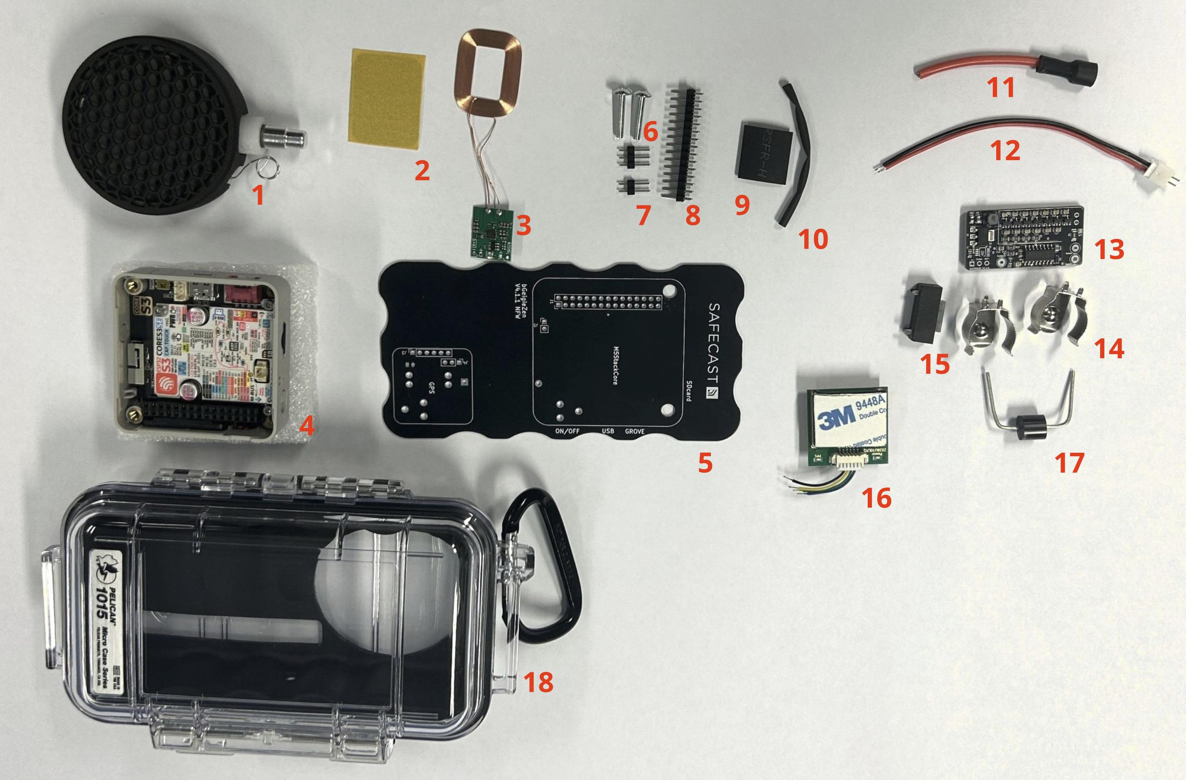

Extra Components
- Battery: 650 mm 3.7V 3000mA unprotected flat-top type
- 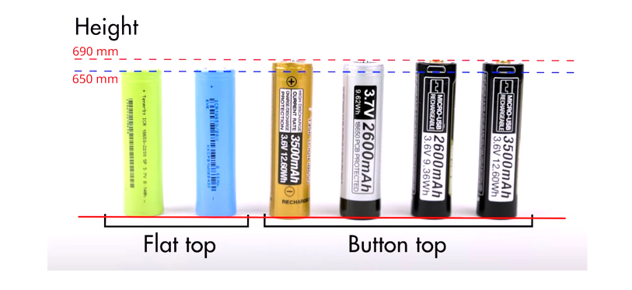

Assembly Steps

1. Prepare the Board
- Solder the 2×15 pin (#8 in parts picture) connector to the board
- Place the pin connector with top up on the board(#5 in parts picture) , turn over the board while holding the pin header
- Solder one corner pin, check alignment, then solder remaining pins
- Solder the 1×3 pin header(#7 in parts picture) for the Safepulse (#13 in parts picture)
- Solder the 1×2 pin header(#7 in parts picture) for the Safepulse(#13 in parts picture)

2. Install Diode, Fuse, and Wireless Charger Connector
- Place the diode(#17 in parts picture) with the white band pointed to the fuse (#15 in parts picture)
- Check orientation and placement carefully
- Solder the diode, fuse, and the wireless charger connector in place
- 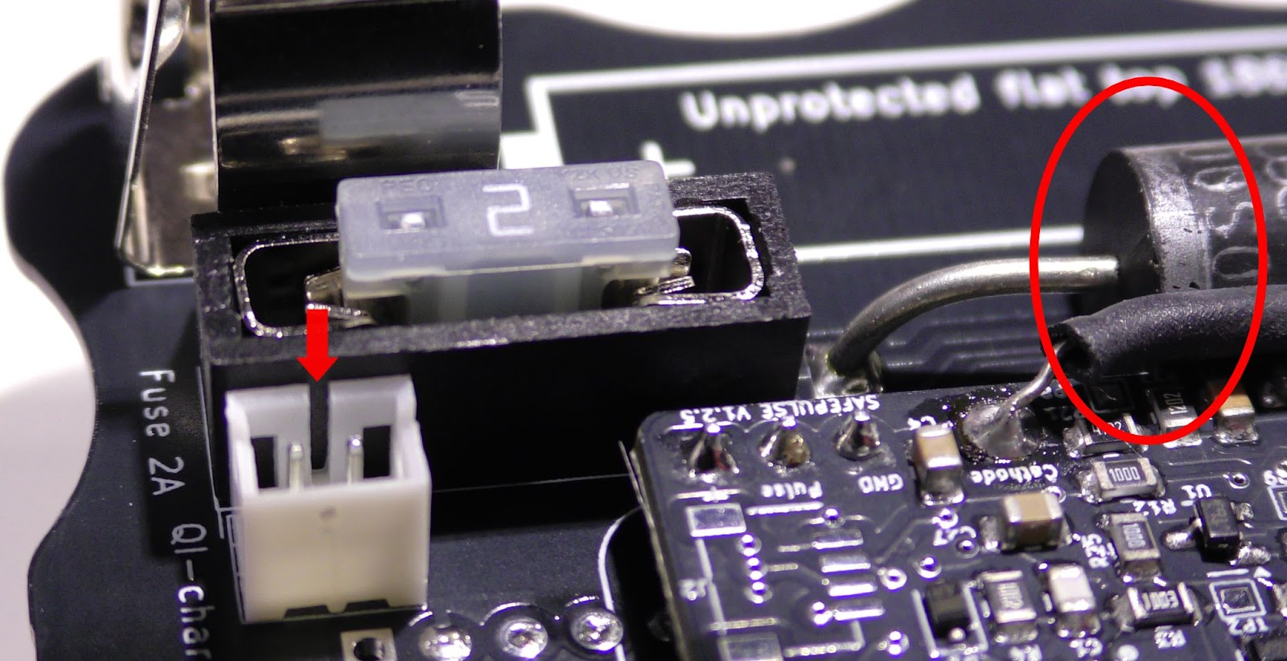
- Cut the extra length of the leads of the diode off.

3. Install the Safepulse Module
- Position the board with the backside up
- Solder all pins of the 3 pins header and the 2 pin header on the board
- place the safepulse and solder the pins
- Solder the wire for the anode connector (red) (#11 in parts picture)

4. Prepare and Install the GPS Module
- For M10050-HT2828 module, follow the connector pins picture below
GPS module | bGeigieZen board
G | G
R | TX
T | RX
V | 5V

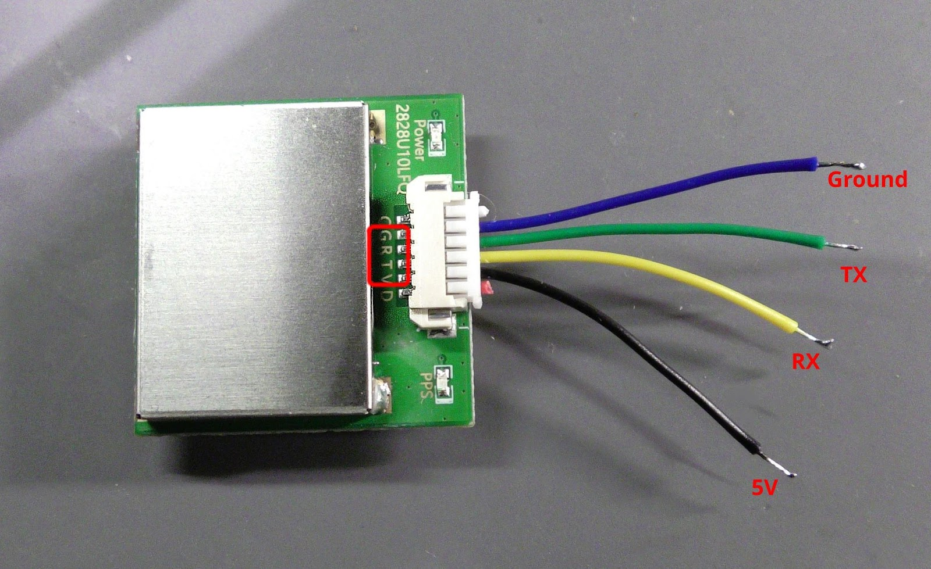
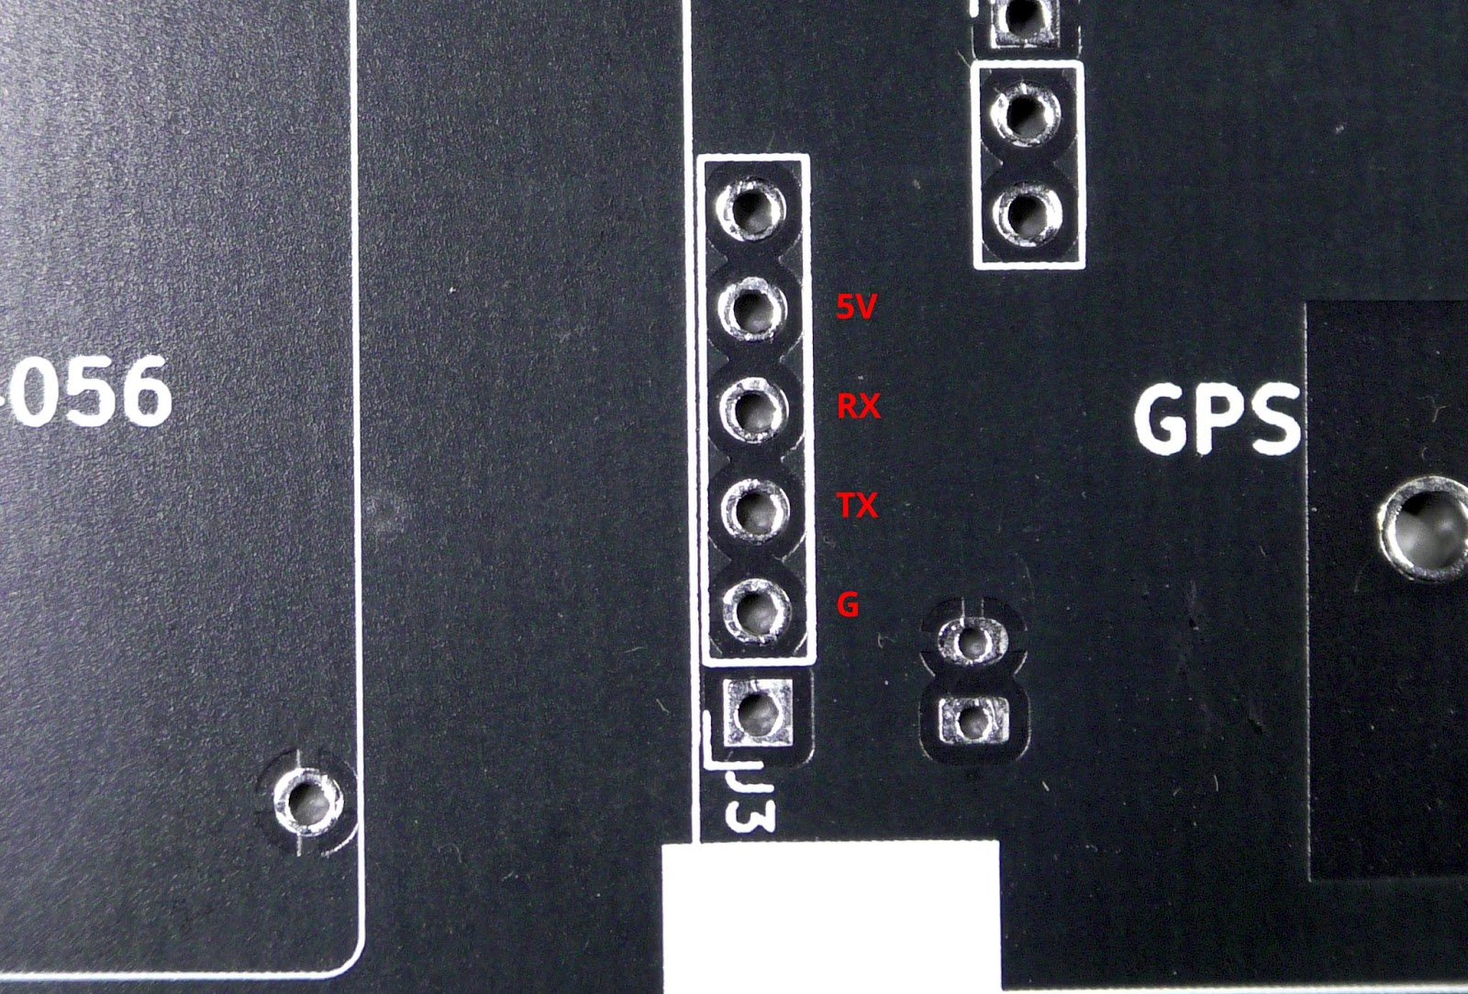

5. Install Battery Holders
- Install battery holder clips in appropriate holes
- Solder one pin of each holder, check alignment, then solder remaining pins
- Ensure flat bottom of the holder touches the board

6. Prepare and Install the Tube
- HANDLE WITH EXTREME CARE - grid is fragile
- Place tube with grid down into case in the cutout hole of the rubber
- remove the 3M stick paper of the tube
- Place board in case without moving tube
- Install M3 15mm screws for mounting M5StackCore (DON'T OVERTIGHTEN)
- Unroll the cathode (blank wire connected to the tube) and place the shrink tube (#10 in parts picture) over the blank wire
- Solder the blank wire to the Safepulse (labled as cathode).
- 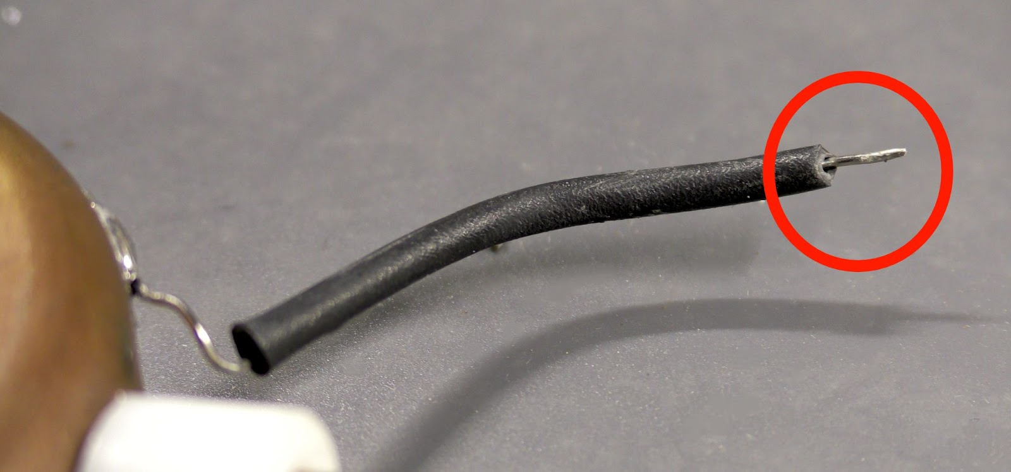
- Connect the anode connector (red wire) to the tube and add protected shrink tube (#9 in parts picture). Heat the shirnk tube to about 120 degree Celcius
- The assambly should now look like(without battery):
- 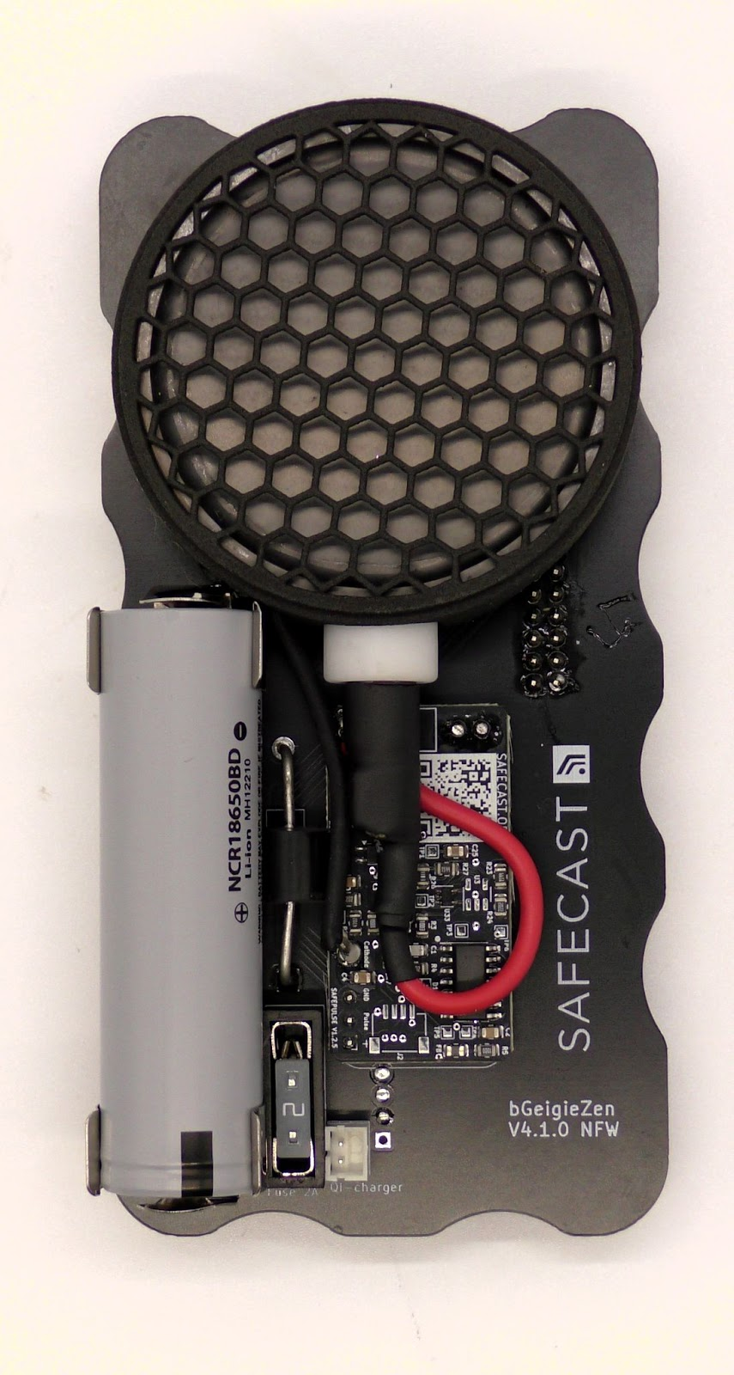
- Insert SD card

7. Final Assembly
- For QI charging:
- Cut hole for receiver cable
- Solder QI receiver (green small board with LEDs) red to plus and black to minus
- Close case (should have soft "rubber touching case" sound)
- Confirm that top of rubber liner is 2mm above the board

Software Installation
- Install USB VCP Driver
- Install M5Burner/UIFlow Firmware Burning Tool
- Connect the M5StackCore via USB-C
- Select your M5StackCore type and search for "Zen"
- Download and burn the firmware
- Configure by editing the SAFEZEN.txt file on SD card

Notes and Tips
- When powering down, wait a few seconds before powering up again
- Ensure the aluminum connector of the anode is firmly screwed on (loose connections cause incorrect counts)
- Most kits already have protective mesh screen on sensor (check before assembly)
For detailed instructions or troubleshooting, refer to the complete manual at Link

